Evaluation of the Horizon project

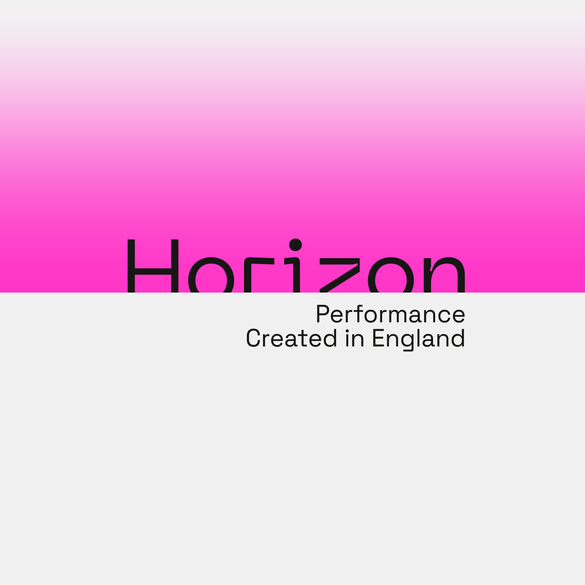

Final Report: Executive Summary

Santra Consulting Ltd.

November 2023

Introduction
Horizon was commissioned by Arts Council England to run an international performing arts showcase of work made in England at the Edinburgh festivals. It was delivered by a consortium of six organisations: Battersea Arts Centre, FABRIC, Fierce, GIFT, MAYK, and Transform, from November 2020 to October 2023.
The aim was to use a new approach to build deep and sustainable collaborations and to celebrate visionary artists and cultural leaders, with a view to significantly rejuvenate the existing ecology of the live performance sectors across the UK.
The consortium worked with Associate partners reflecting different specialisms and art form focuses, and with Artist Advisors. In years 2 and 3 the Associates were: Kakilang (formerly Chinese Arts Now), Tara Arts, The Cocoa Butter Club and Unlimited. The Artist Advisors were Natasha Davis, Seeta Patel and Lucy Suggate.
Due to the Covid-19 pandemic, in Year 1 Horizon was delivered as a digital showcase in 2021. In Year 2 Horizon delivered its first in-person showcase at the Edinburgh festivals, presenting the work of 10 showcase artists/companies, and supporting 8 early-career artists to experience the festivals. In its third year, Horizon delivered another in-situ showcase in Edinburgh, presenting 9 showcase pieces, as well as supporting a further 8 artists to attend the showcase through the Nova Programme. Horizon also supported 6 residencies in 2023.
In July 2022, Dr Ulrike Chouguley (trading as Santra Consulting Ltd) was commissioned to evaluate Year 2 and Year 3 of the Horizon project. The evaluation served a dual purpose:
- Formative evaluation: to monitor and assess progress towards the objectives of the Horizon project and draw out key learnings, with a view to shaping and improving its ongoing delivery.
- Summative evaluation: to look back and assess what has been achieved and what impact the project has had in Year 2 and Year 3, thus helping the project consortium and delivery team to report back to existing funders, as well as making the case for future funding and further development.
The final report presents the findings from the evaluation of the Horizon activities delivered in both years and is based on an extensive scoping phase and research tasks that included online surveys of Showcase artists, Bursary and Nova Artists and Showcase Delegates, as well as interviews with 28 representatives of Consortium and Delivery Team members, Associate Organisations, Artist Advisors, Artists, Strategic Partners and Funders in 2022 and 38 individuals in 2023.

Key findings
Horizon engaged a diverse range of artists, delegates, audiences, industry representatives and participants (see Box below).
Artists & creatives | 61 Showcase lead artists & performers in 19 showcase productions (Target: 8-12 productions) and 8 bursary and 8 Nova artists (Target: 10 per year)  3 Artist Advisors (Target: 4)  6 residency artists/companies (Target: 6)  1,935 employment days for 98 other creatives and specialists (e.g., producers, technicians, etc.)
Delegates & international presenters | 82 delegates in the ‘core’ delegates’ programme (Target: 30 per year)  127 wider delegates engaging with Horizon showcase performances (Target: 100 per year)
Audiences | 7,186 audiences at showcase performances (Target: 3,000)  £67,491 box office revenue (Target: £20,000 per year)
Participants in development activities | 101 artists & delegates at networking events and 115 at social events  31 artists & delegates at online pitching session  19 consortium & delivery team members in sub-group & network meetings
Industry representatives & wider public | 53 industry attendees at CPD & knowledge-sharing events  46 attendees at talks for wider public

The short-term outcomes discussed below focus on the change that occurred as a direct result of the Horizon activities and outputs. The medium-term outcomes are predicted to occur sometime after the actual project intervention; therefore, it is expected to see less evidence for them at this stage.

Short-term outcome 1: Artists have increased international touring prospects and opportunities
The evidence from the evaluation shows that Horizon is successful at facilitating new relationships, especially between artists and delegates. All Showcase and Residency artists reported making new international connections, while the same was true for 50% of Nova and 20% of Bursary Artists. As a result of these new connections, delegates were interested in following with, on average, 3.1 Showcase Artists (2022) and 2.4 Residency Artists (2023). However, there was a ‘hierarchy of opportunities’, with Showcase artists receiving most support and opportunities, followed by Residency and, finally, Nova Artists, which some stakeholders considered problematic in the context of the respective profile of the cohorts.
There was also a feeling that more opportunities for artists (especially Residency and Nova) to engage with the consortium organisations within the context of the Edinburgh showcase would be beneficial to furthering opportunities.
While the evidence suggests that there was greater engagement between Horizon and the wider Edinburgh Festival Fringe context, compared to the previous year, multiple stakeholders still felt a need for Horizon to open up, and closer connect with, the wider Fringe activities, for the benefit of creating more opportunities for artist and delegates alike.
The evaluation further demonstrates that Horizon has played a positive role in increasing artists’ ambitions and understanding of international opportunities and touring. This was particularly relevant to the early-career bursary artists, but also for showcase and Nova artists, despite many of them having prior international touring experience.
The evidence further suggests that Horizon brought together delegates with influence & decision-making ability to commission artists: this year, a smaller proportion of delegates were new to the Fringe, but the cohort was still perceived as different to other showcases, as well as having local and regional influence and decision-making ability.
The evaluation found that there was a good fit between the showcase programming and the expectations and interest of delegates. In particular, Horizon’s showcasing of artists from diverse backgrounds was valued by delegates. However, there was some mismatch in terms of the boldness and innovation of programme (for more discussion, see section 4.2).
Artists have secured support to further develop work for international markets as a result of their participation in Horizon, or are confident they will in the near future. This primarily consists of touring opportunities in England but also some other elements, such as residencies and increased profile.
While to a lesser extent than in 2022, there were still some questions as to whether Horizon sufficiently considered the international potential of an artist in the selection process.
Overall, the evidence suggests that Horizon has clearly increased artists international touring prospects, primarily for Showcase Artists and – to a lesser extent – for Residency and Nova Artists.

Short-term outcome 2: Audiences and delegates have experienced high-quality, bold and diverse showcase performances
The data on artists’ profiles and protected characteristics shows that Horizon attracts a more diverse group of artists than is common across the sector, especially in terms of ethnicity, disability, sexual orientation and socio-economic background. The artists on the Nova programme were entirely from global majority backgrounds. This suggests that Horizon is successful in its aim to showcase artists from diverse backgrounds, however, there was a feeling that there was still further opportunity to include diverse artists more centrally into the main showcase strand. Evidence from the evaluation further shows that Horizon has showcased a great diversity of forms, from durational pieces to a show taking place in a swimming pool.
The evaluation found that the programme has presented bold and innovative showcase performances, pushing the boundaries of work that is generally shown at the Edinburgh Festival Fringe and broadly in line with delegates’ expectations.
Finally, the evidence suggests that the quality of the programme was strong and more consistent this year, although there remained some concerns around the ‘readiness’ of a small number of selected shows. While not raised as frequently by delegates and stakeholders, there are also differences in the scale of work that programmers are used to presenting, especially in European countries, and the work that Horizon is able to present (due to the context of the Edinburgh Festival Fringe and the work that is being produced in the UK at this point of time).

Short-term outcome 3: The Horizon Showcase has demonstrated good practice for a sustainable, care-centred and accessible showcase at the Edinburgh Festivals
The evaluation found clear evidence that the Horizon delivers a care-centred Showcase Model:
- with a strong commitment to fair pay: while residency artists highlighted the (unpaid) additional resources required for the film element, overall, there was a sense that Horizon was clearly delivering on this ambition, with 91% of Showcase and Nova artists (net) agreed that “Horizon had prioritised fair pay of artists”.
- helping to ease the stress and pressure of the showcase situation through the focused networking model and practical support for production management, accommodation and venue bookings etc, although the schedule was felt to be very intense by both artists and delegates
- and a central concern for the wellbeing of artists, with 100% of Nova/Bursary and 69% (net) of Showcase artists agreeing that Horizon had “prioritised the wellbeing of artists”.
In terms of accessibility, Horizon provided opportunities to a significant proportion of artists with access needs across the artist cohorts and many of those felt that they would not have been able to attend a showcase at the Edinburgh Festivals without the support given by Horizon. Nonetheless, some stakeholders noted that this provision of support was inconsistent at times, which was also reflected by this year’s Showcase artists not feeling their individual access needs supported as strongly as the previous year’s cohort. This may have been due to a ‘normalisation’ of the access theme and an assumption that people would raise any access needs by themselves.
In 2023, Horizon almost tripled the number of accessible, BSL/Audio-captioned performances provided as part of the Showcase, compared to 2022 and, within the context of the Edinburgh Festival Fringe, most stakeholders felt that Horizon was successful at delivering an accessible Showcase to audiences. However, there are some differences in access models promoted by Horizon (especially the ‘relaxed’ performances model) and standards used by local venues, which require further consideration.
There was some evidence that the Horizon Showcase has promoted environmental sustainability, through consistently encouraging low-carbon means of travel and the consideration of environmental sustainability as part of the eligibility criteria for funding support. However, stakeholders highlighted that the implementation of a ‘slow touring’ model requires more deliberate selection of delegates with similar artistic interests and within geographical proximity.
The evaluation found that stakeholders recognised a difference in Horizon’s approach to dealing with artists and the experience offered to delegates and artists alike – with the pay model perhaps the most prominently mentioned difference for artists, and delegates highlighting the value of the consortium group leading Horizon. However, differences between the Horizon and other Edinburgh Fringe showcase events and performances were not as strongly felt.

Short-term outcome 4: The capacity of consortium members, delivery team and strategic partners has increased
The evaluation found evidence that Horizon had helped to increase organisational and professional development of consortium organisations, delivery team members and Associates, through capacity-building and skills development, raised profile and recognition, and increasing their financial sustainability.
The findings also support that Horizon has helped to extend and deepen networks nationally, especially between consortium organisations and their strategic partners.
The experience of Artists Advisors was very mixed: while one individual reported some professional development and networking outcomes, the other two individuals did not feel they had benefitted in terms of leadership skills or capacity building.
Horizon is also making a largely positive contribution to Associates, helping them to deliver their organisational objectives. Nonetheless, feedback from one associate organisation suggests that the involvement of strategic partners should become more reciprocal to affect longer-term strategic agendas.
There are also significant concerns by the Fringe Society about the strategic fit of the future Horizon model with their organisational objectives.
Finally, consortium organisations themselves voiced concerns about the strategic alignment of Horizon with individual consortium organisations, as well as with the original vision for the project.

Medium-term outcome 1: England’s live performance art sector has internationalised
With the internationalisation of artists being the primary aim of the Horizon project, artists securing international tour bookings is a key indicator of success. The evaluation shows that Horizon has increased artists’ confidence in obtaining international touring opportunities: 100% of 2023 showcase artists and 86% (net) of 2022 artists were more confident than before their participation in Horizon about securing international touring opportunities. Horizon internal analysis on Return on Investment (ROI) and Artist Income further provides convincing evidence that Horizon has led to additional international touring and income opportunities. For the Showcase and Residency Artists 2021/22, Horizon invested a total of £50,656. This leveraged £195,406 in investment from international partners, mostly for performances and showcases at other festivals. This shows a ROI rate of 286%. The 2022 Showcase led to additional artist income of £165,500 while additional artist income as a result of participation in the Horizon showcase is projected at £268,800 for 2023.
Horizon is primarily seen as a route to international touring, rather than residencies, exchange or co-creation opportunities, or new commissions, but Showcase artists’ levels of confidence in securing such alternative international work opportunities had nonetheless significantly increased (89% net) in 2023, and slightly increased in 2022 (29% net).
These internationalisation outcomes primarily benefit the artists participating in Horizon and the evaluation suggests that there was a likely positive ripple effect on the wider sector, due to Horizon changing perceptions of work being made in England and providing opportunities at a time when funding opportunities in England are scarce. However, most stakeholders felt that is too early to determine any impacts on the wider sector. Considering the challenging funding landscape for the art sector at the moment, this impact may also be smaller than it may have been in a more positive climate.

Medium-term outcome 2: Awareness of, and engagement with, key issues affecting the live performing arts sector has increased
The evaluation found evidence that Horizon has contributed to increasing awareness of, and engagement with, a range of issues that are central to the future development of the live performance art sectors, although there seemed to be less emphasis on this aspect in the 2023 Showcase, compared to the 2022 edition. Key issues that are promoted are the focus on accessibility, diversity and standards of artist care. While Horizon has considered the issue of environmental sustainability, at present it has been able to make little headway to progressing this agenda within the context of international touring.
Horizon has started exploring new and improved showcase models, including options around digital engagement, an alternative location for the Showcase and identifying key areas of support.

Medium-term outcome 3: The English live performance ecology and art form have diversified and rejuvenated
There is evidence that Horizon has started to impact the live performance ecology: as the national showcase of England, stakeholders feel confident that by giving exposure to artists from diverse backgrounds, Horizon is building the base for wider changes in the industry. The increasingly diverse group of applicants was also anticipated to have a ‘soft effect’ on future curation and diverse artists coming forward for opportunities such as this. However, there is a need to further increase diversity at the decision-making level (the consortium members, in this case) to affect wider change.
The 2022 bursary artists programme was a way of providing experience to emerging artists, while the re-conceptualised Nova programme strand in 2023 was aiming to give an opportunity to learn, develop and network to ‘the next generation of Showcase artists.’ This meant that this year’s Horizon had less impact on emerging artists, but through inclusion of this programme strand it included a wider pool of exciting artists into the national showcase, thus contributing to revitalisation and rejuvenation of the sector.
Finally, Horizon contributed to a diversification and innovation of form at the Edinburgh Festival Fringe, but the impact of this was less relevant on the wider sector, where such work is already produced.

Conclusion
The evaluation shows that Horizon has met almost all its quantitative targets for engagement of artists, delegates and audiences. Horizon has been clearly successful in increasing international touring prospects and opportunities for the artists that participated in the programme. Over the two years, Horizon has developed a diverse and innovative Showcase programme, that challenges the formats generally presented at the Edinburgh Festival Fringe and is considered to be of high-quality by most stakeholders. However, there is further need to consider how diverse artists can be fully represented across the ‘hierarchy of opportunities’ provided by the Showcase, Residency and Nova programme strands.
Horizon set out to positively influence the context of the Edinburgh Festival Fringe and the evaluation clearly found that Horizon has demonstrated good practice for a sustainable, care-centred and accessible showcase within the very inaccessible and challenging context of the Edinburgh festivals. The programme has also helped to increase organisational and professional development and networks of consortium organisations, delivery team members and Associates. However, the impact on Artists Advisors was a lot less transformative and the programme strand requires reconsideration. Horizon has helped to deliver strategic agendas of consortium organisations and many of its partners but there are concerns about the future direction of the programme and how to align these with internal strategic objectives, both among Consortium organisations and, most strongly, the Fringe Society.
In terms of the medium-term outcomes, Horizon has clearly met its aim to internationalise England’s live performance art sector, through securing international touring opportunities (and alternative opportunities, such as residencies) for participating artists. Horizon has also contributed to increasing awareness of, and engagement with, a range of issues that are central to the future development of the live performance art sector and has made some initial steps towards its diversification and rejuvenation. However, it is too early to say whether there will be ripple effects into the wider sector, especially given the current challenging funding context.

This figure does not include the show “I Am From Reykjavik” by Sonia Hughes, which was free and unticketed.
Net agreement shows the sum of positive responses minus the sum of negative responses.

