Horizon
Residency
Easy Read Guide

Summary
 | Battersea Arts Centre, Dance4, Fierce, GIFT, MAYK and Transform are creating a new showcase of performance called Horizon
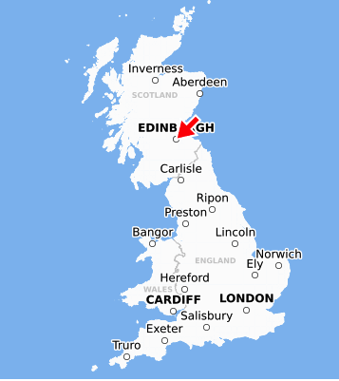 | This work will be shown to be people around the world and at the Edinburgh Festival Fringe.  There are also residencies for artists to develop new work
 | This is an easy read guide to tell you about this opportunity and how to apply

About Horizon
 | Horizon is a collaboration between Battersea Arts Centre, Dance4, Fierce, GIFT, MAYK and Transform
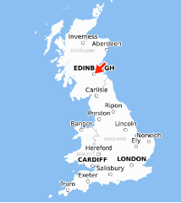 | There will be 8 residencies chosen for Horizon.  You will develop your performance.  You will also go to the Edinburgh Festival Fringe to meet other artists and people who present performance from around the world
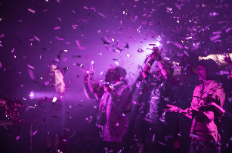 | You can work on these kinds of performance:  - Small size to mid-scale indoor works  - Small size to mid-scale outdoor and sited works  - Works created for one or a few people at a time  - Work that asks what performance is?  - Works that are sound  - Works made with a community of people  - Work that is made to be shown online (cannot be a video version of a live work)

Expectations and Offer

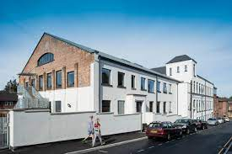  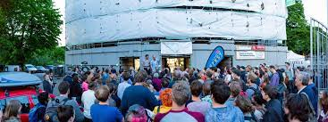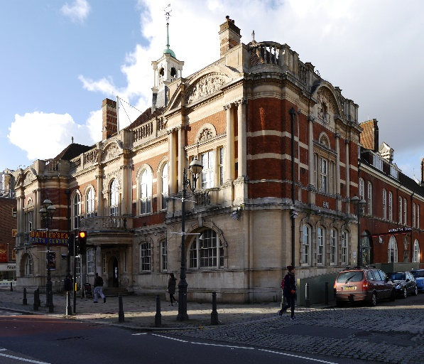 | Each residency will be supported by one of the consortium venues in Birmingham, Bristol, Gateshead, Leeds, London or Nottingham
 | But if you need to go somewhere else we will talk about this with you
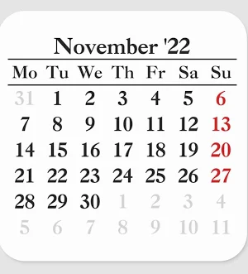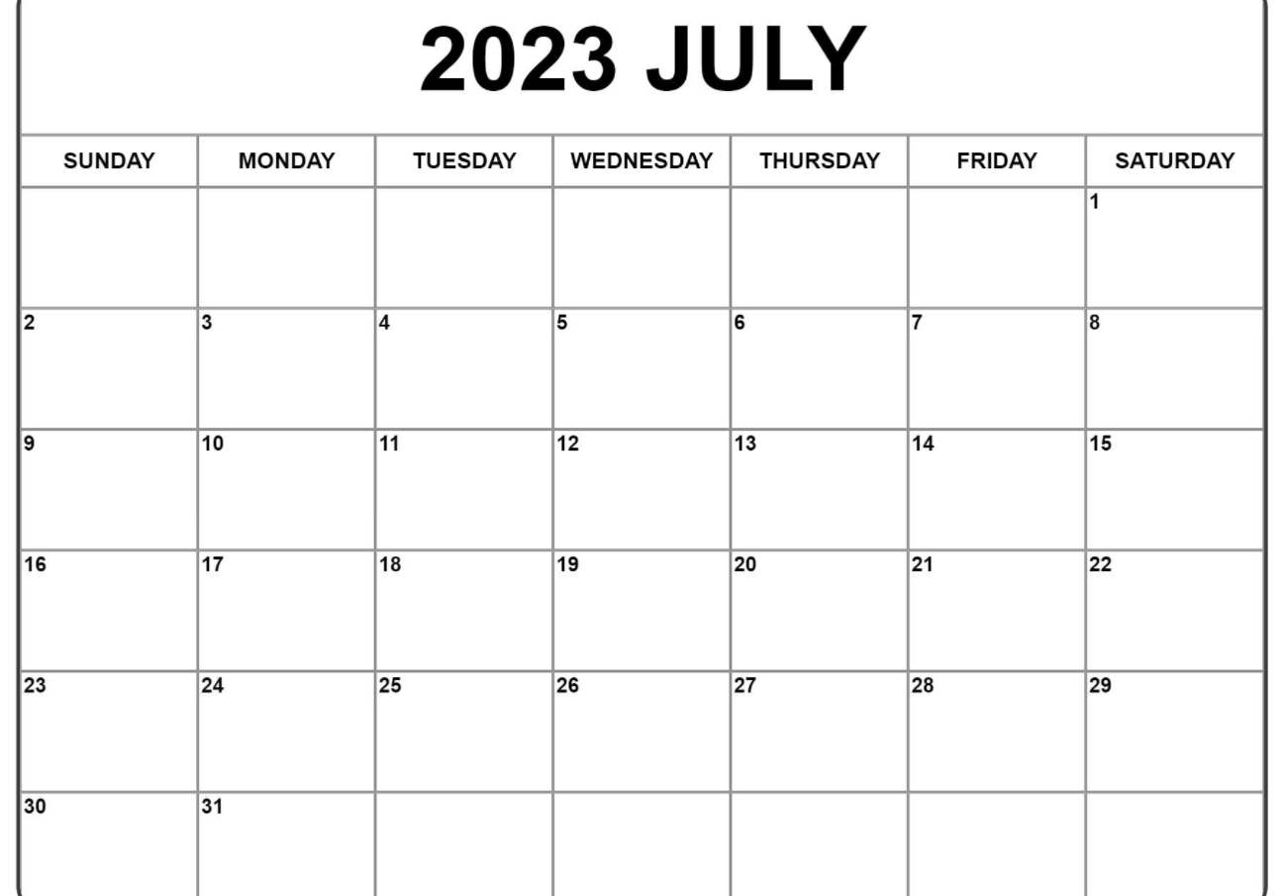 | Residencies will be between November 2022 and July 2023  They can be up to two weeks long
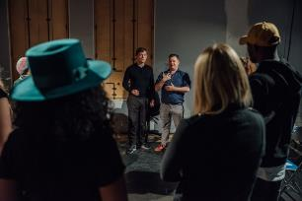 | You need to have an idea and know who you are working with
You will share your residency with people who present performance from around the world.

You will share it in person in Edinburgh in August 2023

You will share it digitally. Horizon will help you get video footage of your residency.
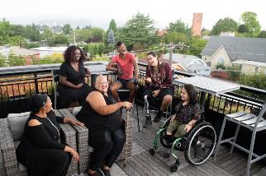 | You or someone from your team will go to Edinburgh in 2023.  You will talk to people and get to know other artists and people who present performance around the world.
 | After your residency you can apply for money to help you meet people around the world who present performance or work that would help you share your performance around the world

What will you get from Horizon?

Up to £5000 to pay for:

- Artists and creative leads
- Things you need for the show
- Sound and lighting equipment
- Insurance (if you don’t have it already)
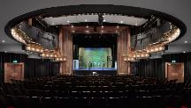 | Horizon will pay for:  - Venue costs  - Travel to and from your residency location (if needed)  - Somewhere to live and money to live on if you are away from home (accommodation and per diems)  - Access costs  - Filming costs to create video for you to share your work  - Somewhere to live, money to live on, artists fee and access costs for a lead artist to go to the Horizon Showcase in Edinburgh in August 2023
Horizon will not pay for:
- Money to run a company
- Money to keep things working (upkeep & maintenance)
 | The residency program is to develop work, not for you to make a finished performance better

You should apply if:
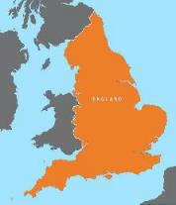 | You live in England
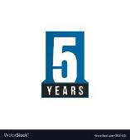 | You have been paid to make art for at least five years
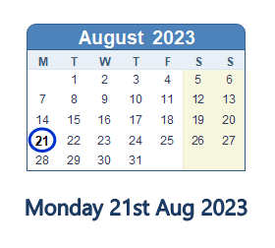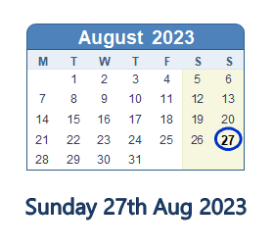  - 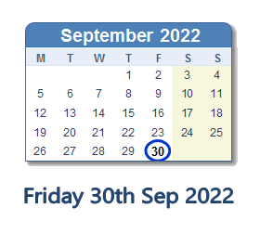 | You and your team can be in Edinburgh from 21 – 27 August, 2023
 | You or other people on your team can take part in the talks, meetings and workshops in Edinburgh
Your show is live performance

Your performance has a strong creative idea
 | You know everyone you’re working with
You are still creating the show
You can have completed another residency but you shouldn’t have finished the show
Horizon would like to work with people who might have been discriminated against in past.
We would like to support work led by:
- Black artists or artists from the global majority (artists who may come from any heritage which is not white)
- South Asian artists
- East Asian artists
- Disabled or D/deaf artists
LGBTQI+ artists
- Artists from a low socio-economic/low income background

You shouldn’t apply if:
You are a student
Or you haven’t been paid to be an artist for the past five years
Your show is only music
Your show is stand-up comedy

How will we decide who is part of Horizon 2023?

A group of people from Horizon will look at your application.

To decide if you will be part of Horizon the people will ask:
- Will being part of Horizon help you show your art around the world? Is this the right time for you to do this?
- Is your show about ideas that are important to people around the world?
- Does including your show help make the performance industry in England fair and involve people with lots of different life experiences?
- Is the show exciting?
- Does your show do something new?
- Does your show feel consistent and finished?

What happens in the application process?
 | There is more information about applying in the Horizon 2023 Residency Application Process, Questions and Timelines Easy Read
 | You apply through our online form
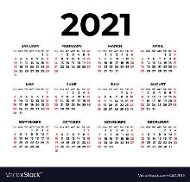 | You can’t submit a project you submitted in 2021
1 | You can only submit one application
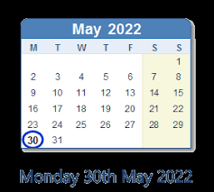 | You should submit your application by 30 May
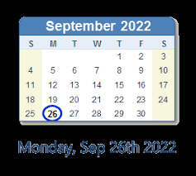 | You will know if your application is successful by 26 September 2022

What if you need more help?
If you need access support for the application we can pay for it.
Email hello@horizonshowcase.uk
When you email put “Access Fund” in the subject line
Horizon will also have some information sessions to help you with the application.
There will be sessions for:
- Everyone
- Just for artists who are D/deaf, disabled, neurodivergent, have a long term health condition or an energy limiting chronic illness
- Just for artists who are from the global majority, Black, from the African diaspora, Caribbean diaspora, East Asian diaspora, South East Asian diaspora, South Asian diaspora, West Asian and Middle East diaspora, Latinx diaspora, Indigenous people and people whose identities may include any of the above.
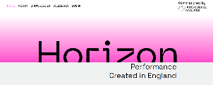 | You can also read answers to some Frequently Asked Questions on our website: https://www.horizonshowcase.uk/
 | Or you can email us with questions at hello@horizonshowcase.uk

