Horizon Residency Budget
Easy Read Guide

What is this Easy Read for?
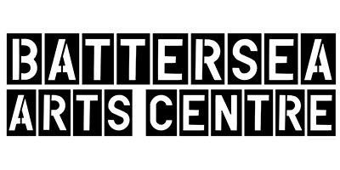 | Battersea Arts Centre, Dance4, Fierce, GIFT, MAYK and Transform want to help share English performance around the world.  They are doing this through a program called Horizon.
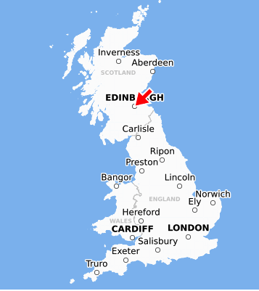 | Performances will be shown to be people around the world and at the Edinburgh Fringe Festival.  There are also chances to meet other artists and people from around the world who show performances.  Or, you can also develop your performance idea. This is called a residency
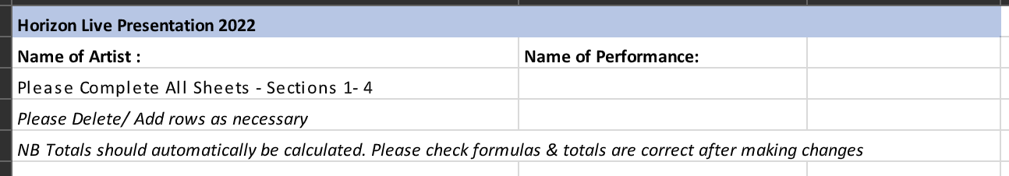 | This is an easy read guide to let you know how to fill out the budget template part of the residency application.

About the Template
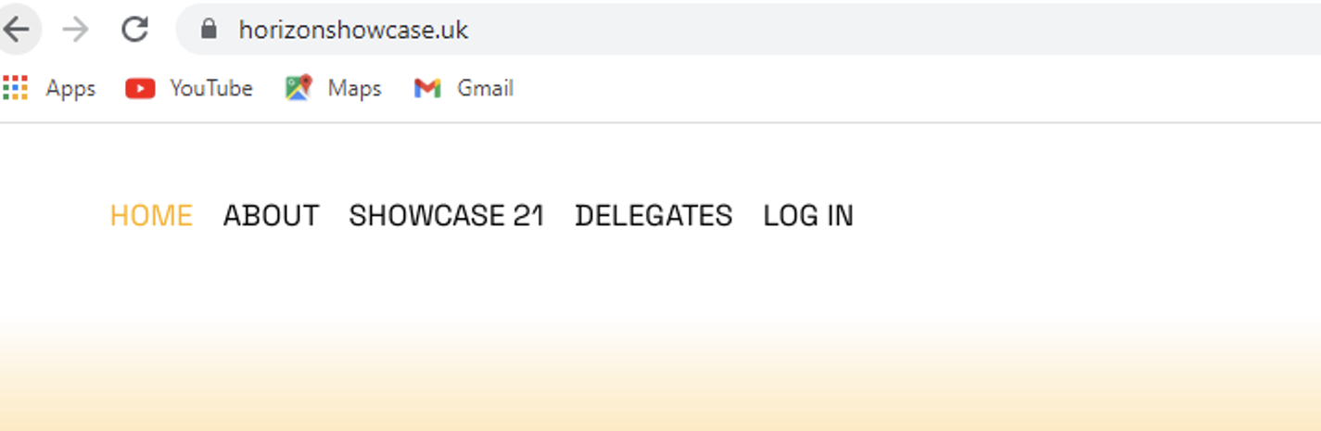 | Please use the Horizon budget template. It will be on the Horizon website:  https://www.horizonshowcase.uk/
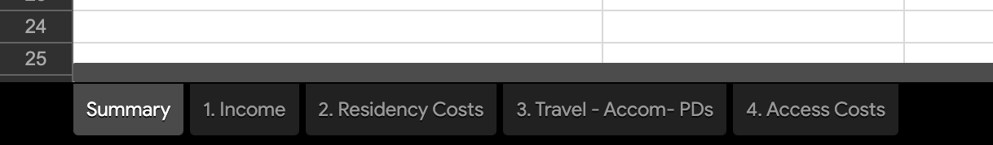 | There are five sheets:  - Summary  - Income  - Residency Costs  - Travel - Accommodation - Per Diems  - Access costs  You need to use all sheets
 | Add VAT if you are VAT registered
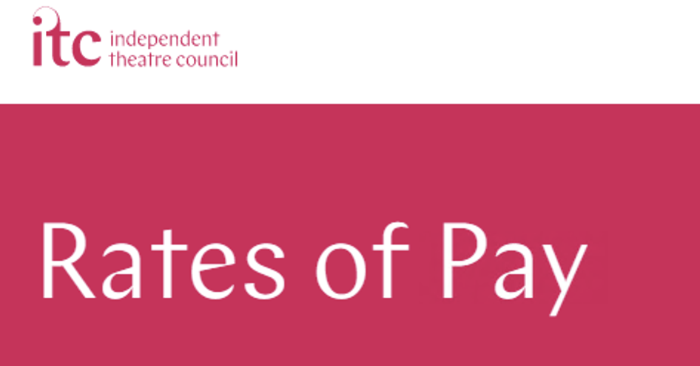 | Please don’t pay people less than they should be paid.  You could decide what people should be paid by looking at the ITC Standards (https://www.itc-arts.org/rates-of-pay/) or other advice.  We think people should be paid between £150 and £350 for each day they are working.  We think people should be paid £100 for each day they are travelling
 | You can ask for up to £5000

What should you ask for money for?
Money for your artists for up to two weeks of work

Money for organizing rehearsals and performances (producing and administration)
Lighting and sound equipment you might need to hire
The cost of getting set, props, costumes and equipment to Edinburgh (Transport & freight)
Money for access for everyone working on the show
Insurance that is only for rehearsal and performing (Insurances specifically for your production period)

Don’t write in the budget:
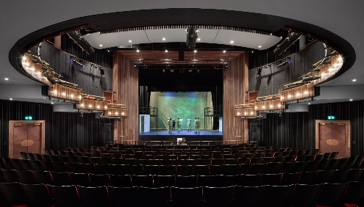 | Money to pay for a place to rehearse (venue hire)
 | Money to film your work, unless this is a major part of making your art
 | A place to live during your residency if you are away from home (Accommodation)
Travel to the place your residency will happen and back to where you came from if you are away from home

Travel to and from Edinburgh for Horizon 2023 (Return travel)
Money to live on during your residency if you are away from home.

Money to live on while you’re in Edinburgh (per diem)

What won’t Horizon pay for?
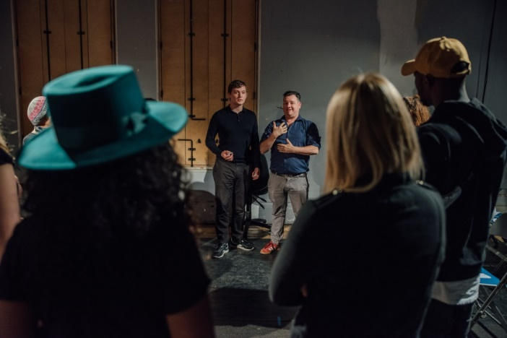 | Rehearsals for a piece of performance that is finished
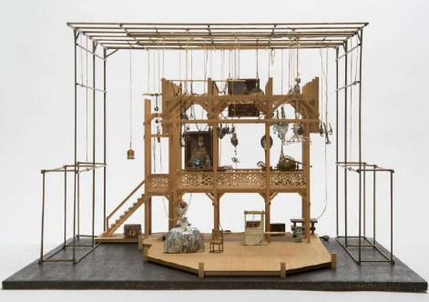 | Costumes, set and props
 | The cost of running a company
 | Keeping things in good repair

This part of the Easy Read tells you a little more about some of the sheets in the budget spreadsheet.
Income:
It’s okay if you don’t have other people or groups giving your performance money. But if you do, please put it in the spreadsheet.
Make sure you include all support, including in kind support

Residency
Make sure you tell us everything you need to do your residency.

This includes:
- Artistic fees
- Producing/admin costs
- Materials and consumables
- Technical hires and other production costs
Please list everyone involved in the residency including:
- Lead artists
- Performers
- Technicians
Please list all the money you need for producing, staff fees and administration
Please list any sound and lighting equipment you need.

You will need Public Liability Insurance and Employers Liability Insurance of £5 million.

Travel, Accommodation and Per diems
If your residency is away from home Horizon will pay for travel, housing and per diems
Please help us guess at the costs by telling us everyone who would need to be at the residency.
Horizon will not pay for international travel.

Access Costs
What access costs do the people working on the show have?
We know that sometimes it’s hard to know your access needs.

Tell us what you know about your access needs in the written part of the application.

We will talk to you to make sure we can meet your access needs.
Access cost do not count towards the £5000 you can ask for

Some of the stock imagery in this Easy Read comes from Disabled and Here, a project creating stock images celebrating disabled Black, Indigenous, people of colour. The photographer credits from Disabled and Here for this Easy Read guide are Tojo Andrianarivo and Chona Kasunga.

