Horizon Residency 2023
Easy Read Guide

Summary
This is an easy read guide to help you apply for the Horizon residency 2023.

Battersea Arts Centre, Dance4, Fierce, GIFT, MAYK and Transform are creating a new showcase of performance called Horizon.

There are also artists who work with Horizon and arts experts, who are Horizon Associates.

Horizon are looking for new live performance to develop.

How do you apply?
 | You will have to apply using Horizon’s online form.
1 Residency project  1 Performance OR | You can apply with your performance or you can apply for a residency.  You can’t apply for both.
You can write your application on a template.

The template will be on the Horizon website: https://www.horizonshowcase.uk/

You will need to submit your application in the online form on the Horizon website when it’s finished.

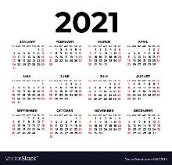 | If you submitted an application to Horizon in 2021, you can’t apply with the same performance idea.

What is in the application?
The application form has a number of questions.
These questions are:
- Contact details
- Confirmation of Eligibility

Confirmation of eligibility will be a checklist
Questions about your performance:

- Title of Performance
- What is it? e.g. Theatre, Dance, cabaret, live art? Etc.
- Description of Performance (up to 300 words or 2 minute video or voice recording)
- What will you focus on in your residency (up to 300 words or a 2 minute video or voice recording)
- Who is working with you?
- A biography of the lead artists or a company description
- Do you have a website or any social media sites linked to your performance?
- If your performance for a particular group? (i.e. 18+, family, etc)
- What stage of development is your work at? (300 words or a 2 minutes voice recording
- What residency or development periods have you finished? What residency or development periods have you planned? Is anyone or an organization helping you?
- When would you like your residency to happen? It needs to happen between November 2022 and July 2023

Documentation
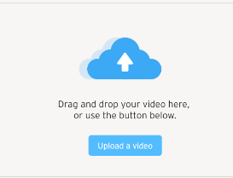 | Upload up to two examples of your art.  The links should not be longer than 5 minutes.  It does not have to be professionally filmed.

Venue and Production Requirements
Questions about what kind of space you need to work in:

- How much space do you need? How big does the stage or playing space need to be?
- Tell us about kind of equipment you might need
- How big do you think the final performance will be?
- Do you have a place your want to be for the residency? (for example, London, Birmingham, Bristol, Nottingham, etc)

Access
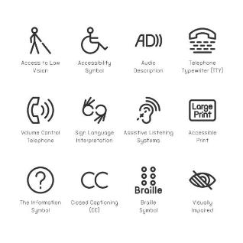 | Questions about your access requirements:  - Let us know if you or the people you work with have any access requirements.  - For example, do you require a support worker, BSL interpreters, or other provision so that you can work with Horizon?  - If you have an access document please send it to Horizon
Finance
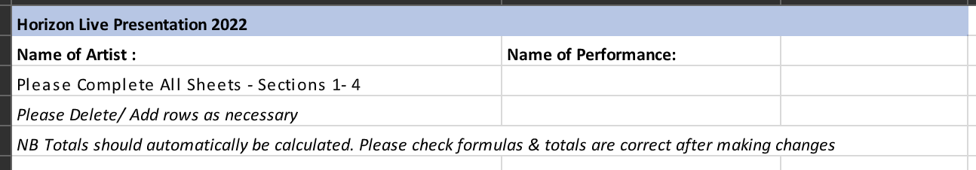 | Please use the Horizon Budget Template to tell us all the costs of your residency

Selection Criteria
All these questions can be answered by:

- Writing 300 words
- Doing a 2 minute video
- Doing a 2 minute voice recording

The application will ask you these questions:

- Can you tell us about any experience you already have performing your work outside of England?
- Why do you want to take part in the Horizon residency now?
- How do you think taking part in the Horizon project will change you or your organization?
- Tell us why you think audiences outside of England will like your performance.

International
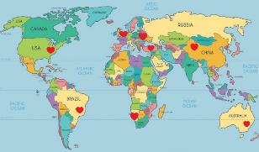 | - Tell us about 3 venues or organizations outside of England who you would like to share your performance with.  If you don’t know of any venues right now, note down in your application which countries you think your performance would do well in and why.

Diversity
Horizon would like to work with lots of different people.

Are you or your company:
- Led by Black artists or artists from the global majority (artists who may come from any heritage which is not white)
- Led by South Asian artists
- Led by East Asian artists
- Led by Disabled or D/deaf artists
- Led by LGBTQI+ artists

It is your choice whether you give this information or not.
Please fill out an Equality & Diversity Monitoring form

The Selection Process
How the Horizon team will decide which residency it will support?
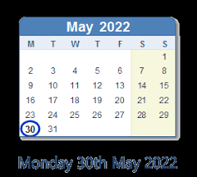 | You need to submit your application by 30th May 2022
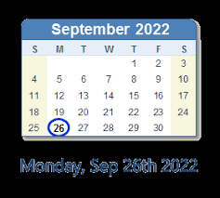 | You will know if your application is successful by 26 September 2022
1, 2, 3 | There will be 3 stages, which will help the Horizon team decide whether you have been successful in your application.
- Eligibility Check

The Horizon team will look at your application and see whether you and your performance meets the eligibility criteria. This is a list of things you and your residency have to have.

If you and your performance are not eligible, the Horizon team will ask you some questions to make sure there isn’t a mistake.

- Application Review

Applications will be looked at and judged by a group of people working for Horizon. There will be 2 or more people who are either staff from a Horizon consortium venue, a Horizon Artist or Associate.

These people will look at applications and judge them against a list of criteria. This is a second list of things the residencies need to have
If your application gets to this review stage, a member of the Horizon team will let you know if your application has been successful or not.

If you aren’t successful, you can ask for feedback, which means the Horizon team will tell you why they did not choose your performance.
- Longlist/shortlist review

Each application will be judged against the criteria (the list of things the performances need to have). The people judging applications will also think about:
- Whether all of the residencies are interesting and different from each other.
- Whether the Horizon programme has everything it needs to support these residencies

If you aren’t successful, you can ask for feedback, which means the Horizon team will tell you why they did not choose your performance.

