Horizon Budget
Easy Read Guide

What is this Easy Read for?
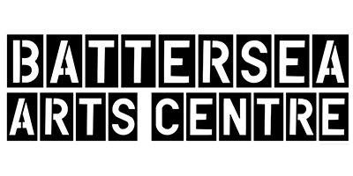 | Battersea Arts Centre, Dance4, Fierce, GIFT, MAYK and Transform want to help share English performance around the world.  They are doing through a program called Horizon.
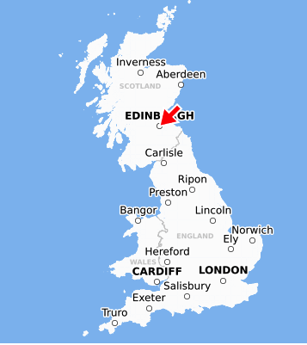 | Performances will be shown to be people around the world and at the Edinburgh Fringe Festival.  There are also chances to meet other artists and people from around the world who show performances.
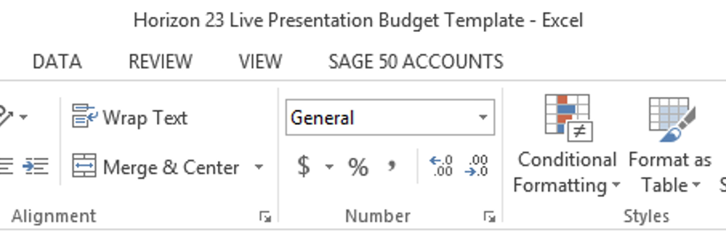 | This is an easy read guide to let you know how to fill out the budget template part of the application

About the Template
Please use the Horizon budget template. It will be on the Horizon website:

https://www.horizonshowcase.uk/

There are five sheets:
- Summary
- Income
- Presentation Costs
- Travel
- Accommodation
- Per Diems
- Remount costs

You need to use all sheets
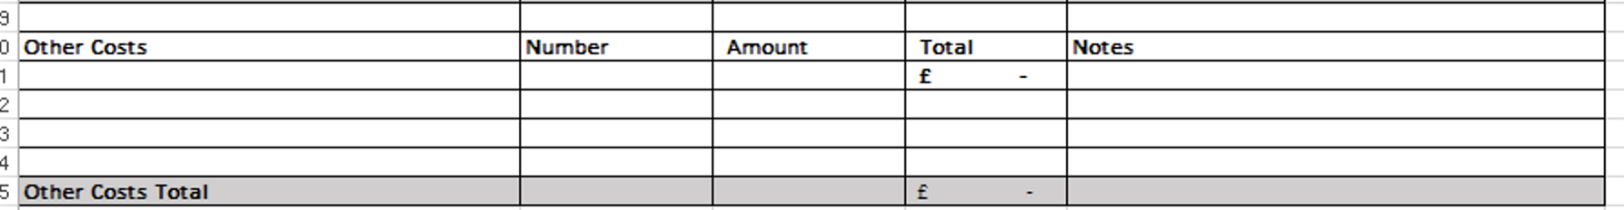 | If you have other costs that don’t fit in these categories use ‘other’
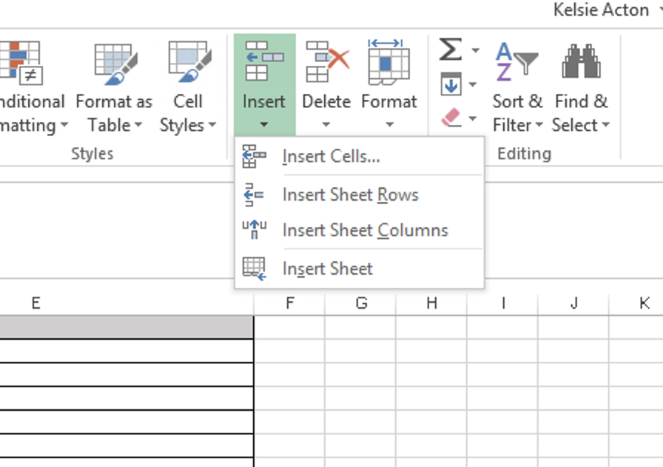 | If you need more rows just add them
 | Add VAT if you are VAT registered
 | If you don’t need one of the things in the worksheet just put £0
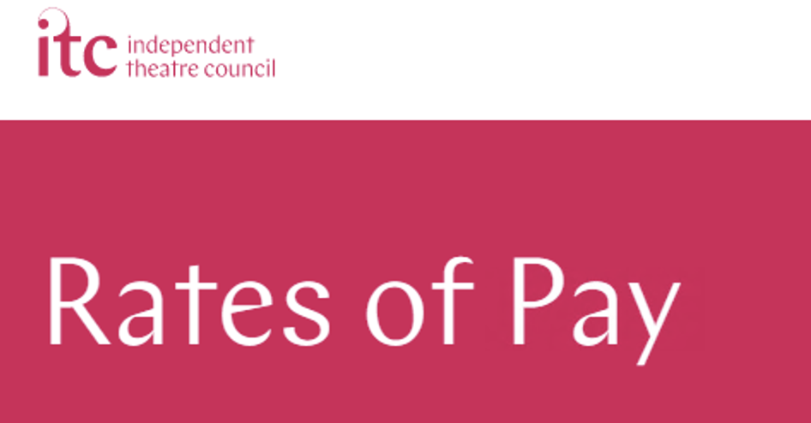 | Please don’t pay people less than they should be paid.  You could decide what people should be paid by looking at the ITC Standards (https://www.itc-arts.org/rates-of-pay/) or other advice.

What should you ask for money for?
 | Money for your artists for seven days of work in Edinburgh (artistic fees)
 | Money for organizing rehearsals and performances (producing and administration)
 | Lighting and sound equipment you might need to hire
 | The cost of getting set, props, costumes and equipment to Edinburgh (Transport & freight)
 | Things that will get used up during the show (Consumables directly related to the show)
 | The money you pay to perform your show (Royalties & Performing Rights)
 | Money for access for everyone working on the show
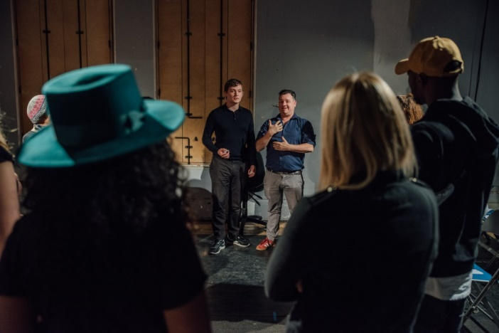 | Money to rehearse your show for one week (Up to 1 week remount costs)
 | Insurance that is only for rehearsal and performing (Insurances specifically for your production period)
 | Money to tell people about your show (Eligible marketing costs)

Don’t write in the budget:
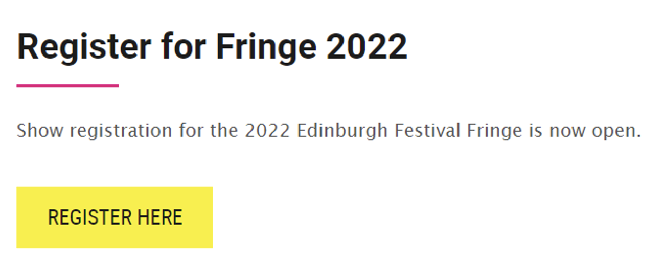 | Money to pay to be in the Edinburgh Fringe (registration costs)
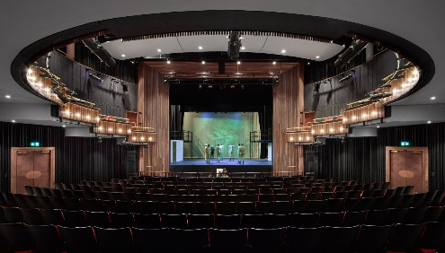 | Money to pay for a place to perform (venue hire)
 | A place to live in Edinburgh while you’re performing (Accommodation)
 | Travel to Edinburgh and back to where you came from (Return travel)
 | Money to live on while you’re in Edinburgh (per diem)
 | Money for music in the performance (PRS and PPL)
 | Money to make the performance more accessible to people who watch it (Audience accessibility)
 | Money people will pay to watch the performance (box office)
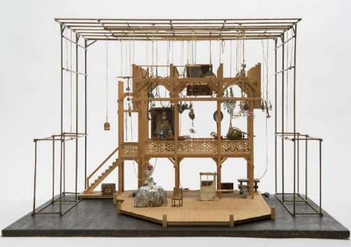 | Money to make a new performance like design or writing fees
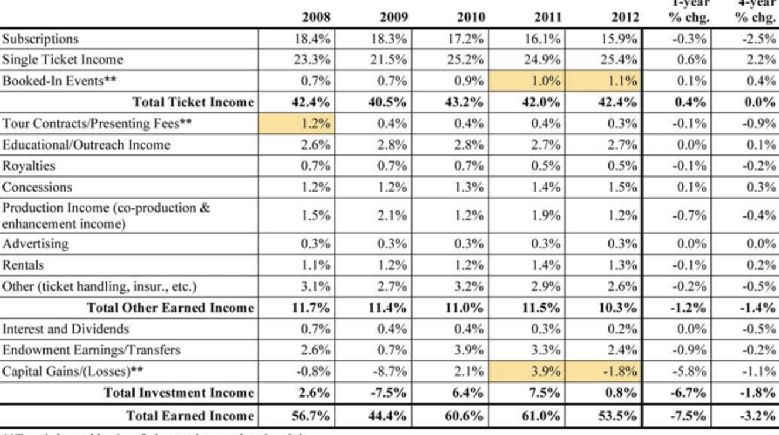 | Money to run a company (overheads or core costs)
 | Paper that tells people about your performance (print marketing materials)
 | Repairing things that might get broken (Upkeep and Maintenance)

This part of the Easy Read tells you a little more about some of the sheets in the budget spreadsheet.
Income:
It’s okay if you don’t have other people or groups giving your performance money. But if you do, please put it in the spreadsheet.
Horizon will keep the money that people pay to see your show in Edinburgh

Presentation
 | Make sure you tell us everything you need to perform in Edinburgh
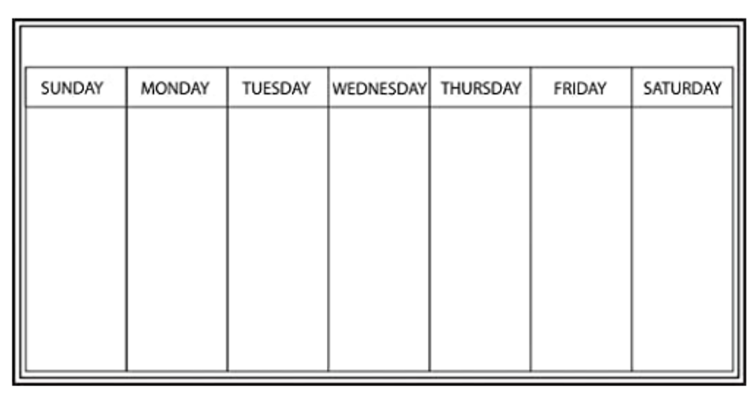 | You will be in Edinburgh for seven days. This includes setting up your performance and taking it out of the theatre.
 | Horizon will pay £100 for each person, each day they are travelling (per diem)
 | Horizon will only pay for people who need to be in Edinburgh to make the show happen

Technical Hires
Most of theatres in Edinburgh don’t have a lot of light and sound equipment.
You can’t know exactly what you will need so will need to guess what equipment you need and how much it will cost.
If you go to Edinburgh we will talk to you about what you need and if we can make it happen.

Access Costs
What access costs do the people working on the show have?
We know that sometimes it’s hard to know your access needs.

Tell us what you know about your access needs in the written part of the application.

We will talk to you to make sure we can meet your access needs.

Insurance
You need to have £10 million of Public Liability Insurance and Employers Liability Insurance
We will only pay for insurance if your insurance doesn’t cover rehearsal and performing in Edinburgh.

Some of the stock imagery in this Easy Read comes from Disabled and Here, a project creating stock images celebrating disabled Black, Indigenous, people of colour. The photographer credits from Disabled and Here for this Easy Read guide are Tojo Andrianarivo and Chona Kasunga.

