Horizon
Live Presentation
Easy Read Guide

Summary
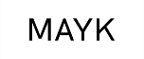 | Battersea Arts Centre, Dance4, Fierce, GIFT, MAYK and Transform are creating a new showcase of performance called Horizon
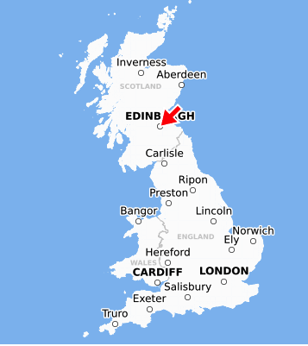 | This work will be shown to be people around the world and at the Edinburgh Festival Fringe.  There are also chances to meet other artists and people from around the world who show performances.
 | This is an easy read guide to tell you about this opportunity and how to apply

About Horizon
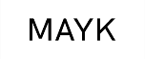 | Horizon is a collaboration between Battersea Arts Centre, Dance4, Fierce, GIFT, MAYK and Transform
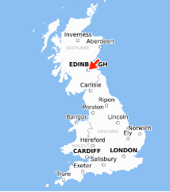 | There will be 8 – 12 performances chosen for Horizon.  You will show your work to presenters from around the world as part of the Edinburgh Fringe Festival
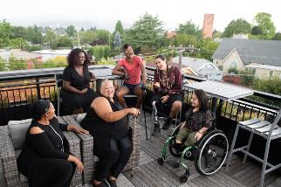 | You will be a part of a group of artists.  You will get to know these other artists as part of Horizon.  There will be events to help you get to know the other artists and people who present performance from around the world.
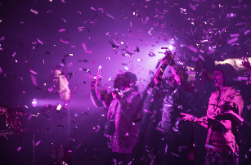 | You can do these kinds of performance:  - Small size to mid-scale indoor works  - Small size to mid-scale outdoor and sited works  - Works created for one or a few people at a time  - Work that asks what performance is?  - Works that are sound  - Works made with a community of people  - Work that is made to be shown online (cannot be a video version of a live work)

Some helpful things to know

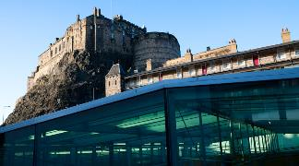 | We are working with these venues:  Dance Base  Summerhall  Traverse  Zoo
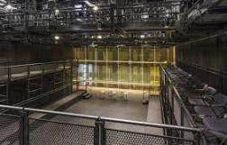 | If you have been setting up performances with another theatre please let us know.
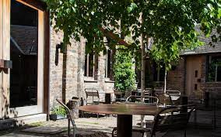 | We are also interested in outdoors and site specific performances
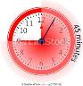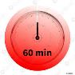 | Usually Fringe performances are 45 – 60 minutes
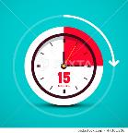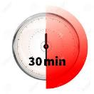 | You will have 15 – 30 minutes to get into the theatre before the show.  You will have 15 – 30 minutes to out of the theatre after the show.
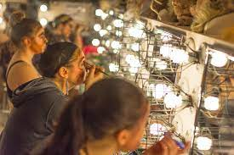 | You might need to share your dressing room.
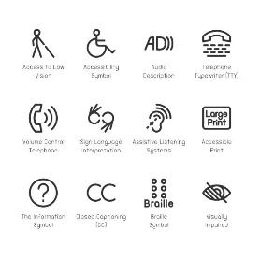 | Please let us know your access requirements
 | We will be flexible about scheduling
 | Horizon will keep the money people pay to see your performance

What will you get from Horizon?

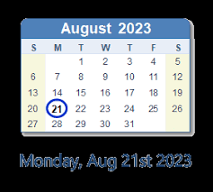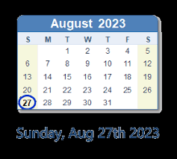  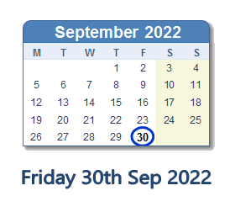 | 1 week of performances between 21 – 27 August
 | We will make sure that people from around the world who present shows see your performance
 | We will also organize activities where you get to know other artists and people who present shows
After performing you can apply for:
- Up to £160 000 to tour your show
- Smaller amounts of money to do work that would help you tour around the world
 | Money for your artists for seven days of work in Edinburgh (artistic fees)
 | A place to live in Edinburgh while you’re performing (Accommodation)
 | The cost of getting you, your team, set, props, costumes and equipment to Edinburgh (Transport & freight)
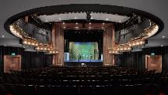 | A place to perform (venue hire)
 | Things that will get used up during the show (Consumables directly related to the show)
 | Money for organizing rehearsals and performances (producing and administration)
The money you pay to perform your show (Royalties & Performing Rights)

The
 | Money for access for everyone working on the show
 | Money to make the performance more accessible to people who watch it (Audience accessibility)
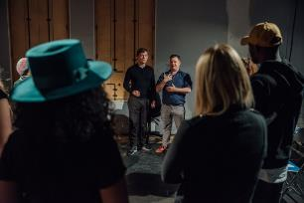 | Money to rehearse your show for one week (Up to 1 week remount costs)

What won’t we pay for?
 | For you to make a new performance
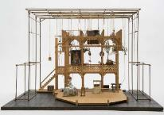 | - Costumes, set, props
 | - Insurance for your company
 | People to run your company (Core Costs)
 | Paper materials to sell your show
 | Keeping equipment and buildings working

You should apply if:
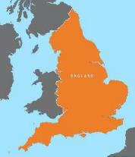 | You live in England
 | You have been paid to make art for at least five years
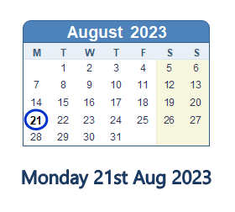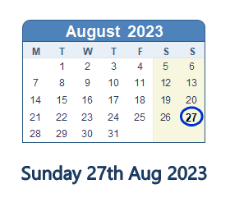 | You and your team can be in Edinburgh from 21 – 27 August, 2023
 | You or other people on your team can take part in the talks, meetings and workshops in Edinburgh
 | Your show is live performance or made for online
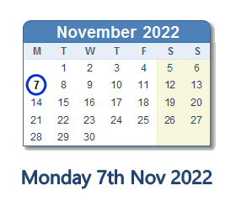 | You can send Horizon video of the show by 7 November 2022  The video doesn’t need to be professional  The sound and picture of the video need to be understandable  The video is of the full show

You shouldn’t apply if:
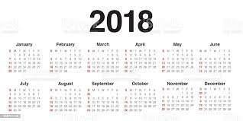 | Your show had its first performance before 2018
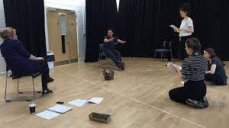 | You are making a new show
You are a student
Or you haven’t been paid to be an artist for the past five years
 | Your show is only music
 | Your show is stand-up comedy

How will we decide who is part of Horizon 2023?

A group of people from Horizon will look at your application.
They will decide if you will be part of Horizon 2023.
To decide if you will be part of Horizon the people will ask:
- Will being part of Horizon help you show your art around the world?
- Is your show about ideas that are important to people around the world?
- Does including your show help make the performance industry fair and involve people with lots of different life experiences?
- Does including your show mean that Horizon has a lot of different art forms and shows?
- Is the show exciting?
- Does your show do something new?
- Does your show feel consistent and finished?

What happens in the application process?
 | There is more information about applying in the Horizon 2023 Live Presentation Application Process, Questions and Timelines Easy Read
 | You apply through our online form
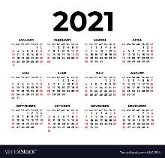 | You can’t submit a project you submitted in 2021
1 | You can only submit one application

What if you need more help?
 | If you want more information about the Edinburgh Fringe you should look at this guide: https://www.edfringe.com/take-part/putting-on-a-show
If you need access support for the application we can pay for it.
Email hello@horizonshowcase.uk
When you email put “Access Fund” in the subject line
Horizon will also have some information sessions to help you with the application.
There will be sessions for:
- Everyone
- Just for artists who are D/deaf, disabled, neurodivergent, have a long term health condition or an energy limiting chronic illness
- Just for artists who are from the global majority, including Black, Brown, Asian and ethnically diverse artists
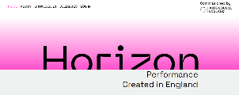 | You can also read answers to some Frequently Asked Questions on our website: https://www.horizonshowcase.uk/
 | Or you can email us with questions at hello@horizonshowcase.uk

