Horizon Presentation 2023
Easy Read Guide

Summary
 | This is an easy read guide to help you apply for the Horizon programme 2023.
Battersea Arts Centre, Dance4, Fierce, GIFT, MAYK and Transform are creating a new showcase of performance called Horizon.

There are also artists who work with Horizon and arts experts, who are Horizon Associates.

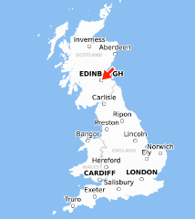 | In 2023, Horizon are looking for new live performance which can be showed at Edinburgh Festival.
You can apply for your performance to be in in the Horizon programme for 2023.

You can ask for money and support from the Horizon team to help improve your performance.
Live Presentation  Residency | You can submit a Live Presentation application, which will describe your live performance.  Or you can also apply for the Residency programme.  A Residency is a period of time where you can get lots of support from an arts venue or a programme like Horizon to work on a project.  This Easy Read will tell you about how to apply to the Live Presentation.
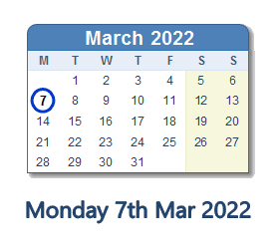  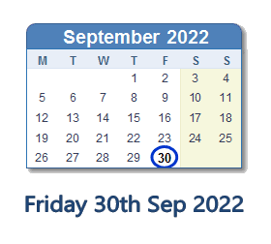  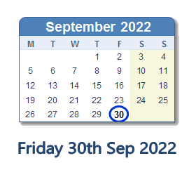 | You can apply from 7 March, until 30 September 2022.
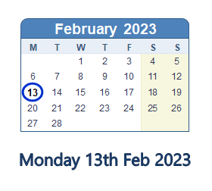 | There will be 4 stages to the application.  If your application is successful you will know by 13 February 2023.
How do you apply?
You will have to apply using Horizon’s online form.

There is also an application for a Residency.

1 Residency project  1 Performance OR | You can apply with your performance or you can apply for a residency.  You can’t apply for both.
You can write your application on a template.

The template will be on the Horizon website: https://www.horizonshowcase.uk/

You will need to submit your application in the online form on the Horizon website when it’s finished.

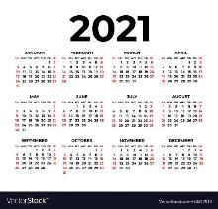 | If you submitted an application to Horizon in 2021, you can’t apply with the same performance or residency in 2022.

What is in the application?
 | The application form has a number of questions.
These questions are:
- Contact details
- Confirmation of Eligibility

Confirmation of eligibility will be a checklist
Horizon would like to work with lots of different people.

Are you or your company:
- Led by Black artists or artists from the global majority (artists who may come from any heritage which is not white)
- Led by South Asian artists
- Led by East Asian artists
- Led by Disabled or D/deaf artists
- Led by LGBTQI+ artists

It is your choice whether you give this information or not.
Questions about your performance:

- Title of Performance
- How long is it?
- What is it? e.g. Theatre, Dance, cabaret, live art? Etc.
- Description of Performance (up to 250 words or 2 minute video or voice recording)
- Who is working with you?
- Can you tell us about the artists or company?
- Do you have a website or any social media sites linked to your performance?
- If your performance for a particular group? (i.e. 18+, family, etc)
- Tell us the date and venue where your performance was first performed.

The Horizon team are very interested in seeing your live performance so they can decide if it should be in Horizon.

Tell us about any performance you are doing between 1 March – 1 November 2022 in your application. Make sure you include performance dates and venues.

4 weeks | If you would like the Horizon team to see your performance, you will need to submit your application 4 weeks before your performance will happen.
Your performance | If your performance will happen before 30 April 2022, you can email hello@horizonshowcase.uk to tell them you are going to apply and to let them know about your performance dates and venue, so the Horizon team can come.
Questions about what your performance needs:

- How much space does your performance need? How big does the stage or playing space need to be?
- Does your performance need to be performed in a particular space? (e.g. black box studio theatre; stage with dance floor; a particular site like a school or a library?)
- Is your performance for a specific number of people?
- Are there groups of people who shouldn’t see your performance? For example, should young children see your performance?
- Tell us about the:
  - Set
  - Lighting
  - Sound
  - Any other tech
  - Any other equipment your performance will need
- If you have already started talking to a venue in Edinburgh, or if there is a venue you would like to show your performance in, please let us know.
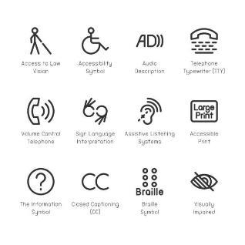 | Questions about your access requirements:  - Let us know if you or the people you work with have any access requirements.  - For example, do you require a support worker, BSL interpreters, or other provision so that you can work with Horizon?  - If you have an access document please send it to Horizon
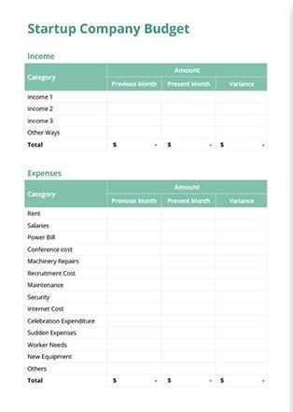 | Questions about how much money you will need:  - How much will your performance cost?  - How much money are you asking for, from Horizon?  You will need to submit a budget for your performance. A budget will need to show:  - How much money you have  - How much money you are asking Horizon for  - What you are going to spend this money on (ie artists fees, costumes, music)
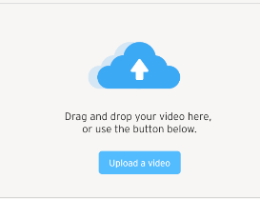 | Extra things to submit with your application:  - A video of your performance. This needs to show your whole performance. The video must be clear so the performance can be easily seen and all sound must be easy to hear.  - A video or link to any other performances you have created. This can be up to 5 minutes long.

Showing your work in other countries
 | The Horizon team would like to share performances with countries outside of England.
All these questions can be answered by:

- Writing 250 words
- Doing a 2 minute video
- Doing a 2 minute voice recording

The application will ask you these questions:

- Can you tell us about any experience you already have, in performing your work outside of England?
- Why do you want to take part in the Horizon project now?
- How do you think taking part in the Horizon project will help you make your work better?
- Tell us why you think audiences outside of England will like your performance.

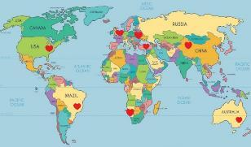 | - Tell us about 3 venues outside of England who you would like to share your performance with.  If you don’t know of any venues right now, note down in your application which countries you think your performance would do well in and why.
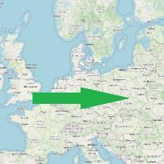 | The application will also ask you how much it will cost a venue outside of England, to host your performance.  This will give the Horizon team a better understanding of where your performance might work well.

The Selection Process.
How the Horizon team will decide which performances will be in the Horizon programme for 2023.
1, 2, 3, 4 | There will be 4 stages, which will help the Horizon team decide whether you have been successful in your application.
- Eligibility Check

The Horizon team will look at your application and see whether you and your performance meets the eligibility criteria. This is a list of things you and your performance have to have, which shows the Horizon programme is right for you and your work.

If you and your performance are not eligible, the Horizon team will let you know.

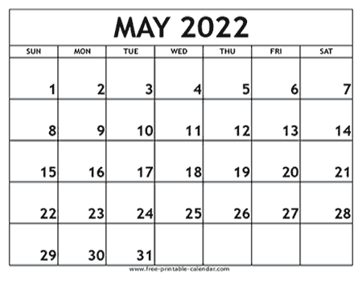  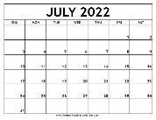  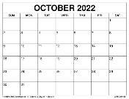 | - Application Review  Applications will be looked at and judged by a group of people working for Horizon. There will be 2 or more people who are either staff from a Horizon consortium venue, a Horizon Artist or Associate.  These people will look at applications and judge them against a list of criteria. This is a second list of things each performance has to have in order for those performances to be included in the Horizon programme 2023.  This review will happen in May, July and October 2022.
If your application gets to this review stage, a member of the Horizon team will let you know if your application has been successful or not. If it has successful, your application will go to the 3rd stage and someone from the Horizon team will come to see your performance.

If your application has not been successful, your performance cannot be included in the Horizon programme for 2023.

If you aren’t successful, you can ask for feedback, which means the Horizon team will tell you why they did not choose your performance.
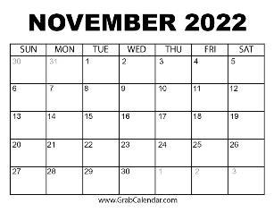 | - Long list review  All applications that have got to this stage will be judged against the criteria (the list of things the Horizon team need to see) again.  This will be done by staff from a Horizon consortium Horizon Artists and Associates, and some people who present performances in other countries.  This will be done in November 2022.
If your application has got to the long list review, you will be called or emailed by the Horizon team, who will tell you if your application has been successful or not.

If you have been successful, your application will go to the 4th stage.

If your application has not been successful, your performance cannot be included in the Horizon programme for 2023. If you receive this news, you can why you weren’t chosen.
- Short list review
Applications will be reviewed again by staff from the Horizon consortium venues; Horizon Artists, Horizon Associates and Edinburgh Festival venues.

This is the final review stage.

Each application will be judged against the criteria (the list of things the performances need to have). The people judging applications will also think about:

- Whether all of the performances together will make a really good Horizon programme for 2023.
- Whether the Horizon programme has all the money needed to support these performances
- If it is possible to put these performances on in Edinburgh Festival (for example, if some performances need a lot of complicated sound and lighting, it might not be possible for this performance to be shown at the festival).
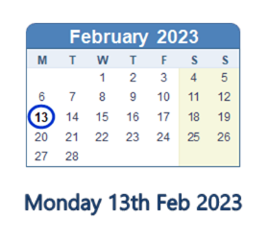 | If your application is successful, you will be called or emailed by the Horizon team, who will tell you your performance will be included in the Horizon programme for 2023.  This will happen by 13 February 2023.

